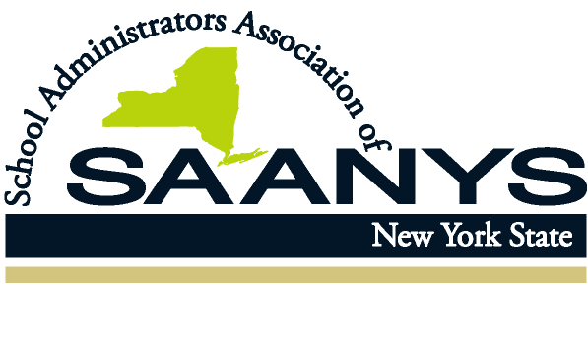
8 Airport Park Boulevard
Latham, New York 12110

Phone: (518) 782-0600
Fax: (518) 782-9552
www.saanys.org

KEVIN S. CASEY
Executive Director

June 11, 2020

Sent Via Email (Shannon.tahoe@nysed.gov)

Dear Interim Commissioner Tahoe:
Thank you for the opportunity to provide comments on the guidance disseminated by the NYS Department of Health regarding In-Person Special Education Services. I do find that there are several parts of the guidance for which we have questions or concerns.
- Page 2 – Section titled Before Opening – 2nd bullet:
The last sentence at the end of the second bullet states “provided, however, that students receiving special education services and instruction are entitled to the opportunity to receive in-person instruction.” This sentence would benefit from clarification that entitlement to in-person instruction is dependent upon the school district’s decision to operate a summer special education term. As the Executive Order is permissive, that sentence makes it seem as if a student is entitled to in-person services as a mandated service. Lack of clarity could result in unnecessary tension between parents and school districts.
- Page 2 – Section titled While Operating, subsection “Adopt healthy hygiene practices” – 2nd bullet:
This bullet states “Encourage, but do not require students to wear acceptable face coverings.” The bullet then proceeds to discuss face coverings for children under two and anyone who medically cannot tolerate a face covering. The first sentence is broad and appears to exempt all students from wearing face masks unless the student decides otherwise. The flexibility of allowing students to forgo wearing masks is surprising, and not consistent with our understanding of prior guidance (see Executive Order 202.17 and DOH Interim Guidance on Executive Orders 202.17 and 202.18). In our work with districts on reopening schools, very few administrators advocate for not having students wear face coverings. This guidance should be clarified, as it potentially has significant impact on guidance and policy for the reopening of schools.
- Page 3 – Section titled While Operating, subsection titled “Adhere to appropriate social distancing” – 4th bullet:
The bullet states “Limit gatherings, events, and extracurricular activities to those that can maintain social distancing, support proper hand hygiene, and restrict group size to no more than ten students at any given time, as feasible.” Although it is doubtful that there will be widespread, if any, offerings of extracurricular activities during a special education summer term, the possible extension of this guidance to a fall reopening could be problematic. It makes us wonder if that particular bullet point is advisable at all.

- Page 4 – Section titled While Operating, subsection titled “Identify signs and symptoms of COVID-19 – 3rd bullet:
This bullet point states “Implement mandatory health screening assessment (e.g. questionnaire, temperature check)…” Like the first point made above, prior guidance has indicated that temperature checks are suggested, but not mandated. The quoted language includes temperature checks as an example of “mandatory health screening…” (I note a similar critique is applicable to DOH reopening guidance to employers. The temperature check can be read as either permissive or mandatory. We are uncertain if this ambiguity is by design.). Further clarity is needed if this guidance becomes the basis for future guidance for the reopening of schools.
Lastly, we urge the Governor’s Reimagine Education Advisory Council to remain sensitive to the need of districts for as much lead time as possible when it comes to implementing new guidelines. I hope that this is helpful for your next meeting of the Council. Should you have any questions or would like to discuss the guidance further, please do not hesitate to contact me.
Sincerely,
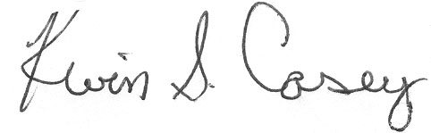
Kevin Casey
Executive Director

