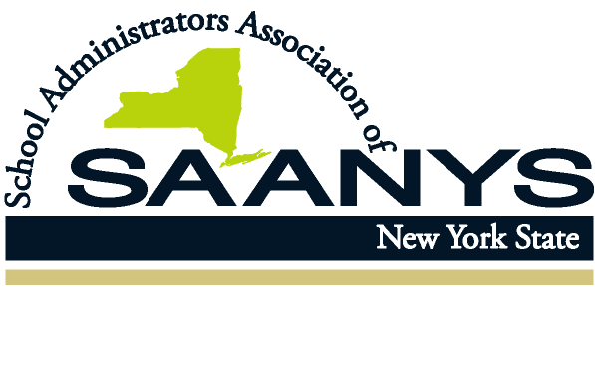
8 Airport Park Boulevard
Latham, New York 12110

Phone: (518) 782-0600
Fax: (518) 782-9552

www.saanys.org
KEVIN S. CASEY
Executive Director

May 12, 2020

The Honorable Andrew M. Cuomo
Governor
State of New York
New York State Capitol Building
Albany, NY 12224

Dear Governor Cuomo:
I am writing on behalf of the members of the School Administrators Association of New York State to express our deep disappointment that the Reimagine Education Council does not include principals, building level administrators or program leaders. As conceptualized, this advisory group was formed to take lessons learned during the pandemic and apply them to building a better educational system. We applaud this forward thinking and submit that principals and building level administrators have seen firsthand the hard lessons learned, and are a critical voice to have represented on the Reimagine Education Advisory Council.
Every day, across the state, principals have been coordinating meal and child care operations, managing distance learning, ensuring the safety of staff and easing the anxieties and fears of students, staff, and community members during this crisis. They are the front-line workers in education and have seen the gaps in our current system. They understand the connectedness of education and mental health, of technology and inequality and the importance of care and support. They can imagine a better educational system because they work toward it daily.
The Reimaging Education Advisory Council should not move forward without the participation of principals and building level administrators. We implore you to reconsider the composition of the group to include these professionals.
Sincerely,
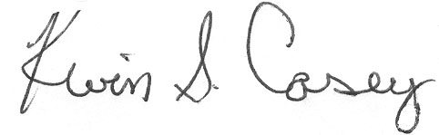
Kevin S. Casey
Executive Director

